Glossary

Control Hub:

Robot Controller Console
Local network created by the Control Hub to program and manage the device. the Control Hub has a name that begins with "FTC-" or "FIRST-" followed by four characters that are assigned randomly. The default password for the network is "password". Can be accessed through a USB connection (to the USB-C port on the Control Hub) from the REV Hardware Client or through a web browser

REV Hardware Client
Has a Robot Controller Console built in. Can connect to the Control Hub through a USB connection to the USB-C port on the Control Hub.

Driver Station App
Application that runs on the Driver Hub (or Android Phone) and connects to the Control Hub

Driver Station Device (Driver Hub or DS Phone)
An Android device that runs the Driver Station App that interacts with the Robot Controller App running on REV Control Hub. It sits with the team drivers. It has one or two Gamepads connected to it

Driver Station Carrier
Mount the Driver Station Device? Used for component management

Gamepad
Connects to the Driver Station Device

Commercial Off The Shelf - COTS

Control Hub

XT-30 Connector
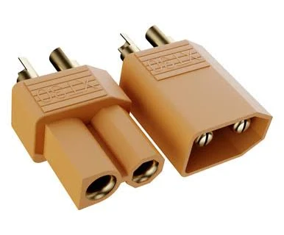

XT-60
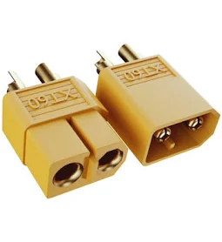

JST-VH Connector (2pin) – Japan Solderless Terminal
Used to power the motors
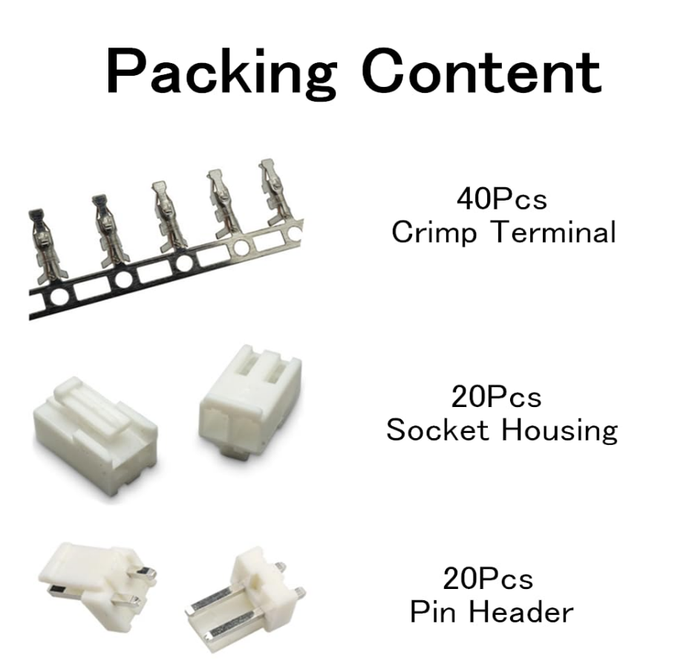

JST-PH Connector (4pin) – Japan Solderless Terminal
Used to connect to motor quadrature encoders
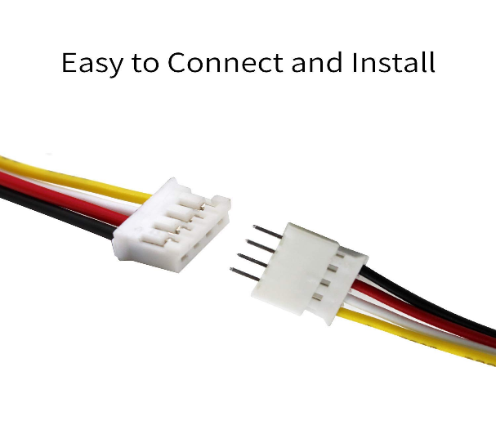

Robot Controller App
App that runs on the Robot Controller Android Device (REV Control Hub) and controls the Robot

Robot Controller Android Device – REV Control Hub
Mounted onto the robot. Acts as the brains of the robot. Tells the robot what to do. It runs the Robot Controller App. It can talk to the robot’s motors, servos and sensors. Can communicate with the REV Expansion Hub through a serial connection
- REV Control Hub is an Android device built into the same case as a REV Expansion Hub and connects to it using an internal Serial Bus

REV Expansion Hub
An I/O module. Once REV Expansion Hub is connected via USB with an Android Smart Phone a pop-up will ask you if it was ok to associated the newly detected USB device with the Robot Controller App

Inter-Integrated Circuit – I2C

USB Video Class camera – UVC Camera
Any UVC compliant camera should work with the system. Calibration of the camera is required and a calibration file should be created. Details on how to create a calibration file can be found in the comments of the teamwebcamcalibrations.xml that is available as part of the ftc_app project folder. You need a stream-enabled Op Modes. Once the OpMode is initialized go to the main menu in the Driver Station App (the 3 dots) and select Camera Stream. The Camera image will appear on the Driver Station . App screen. Manually touch the image to refresh it. To conserve bandwidth only one image is sent at a time. The Camera Stream is only available during the Init Phase of an OpMode. You must ensure that the Vuforia library is activated in your OpMode before the waitForStart command. Alternatively the Camera Output can be viewed on a display monitor connected into the HDMI port on the REV Control Hub.

Op-Mode or Operational Mode

Universal Asynchronous Receiver Transmitter - UART port
is a hardware communication protocol that allows two devices to exchange serial data:

Motor Modes
Motor settings that determine what commands a motor will respond to and how. Most programmers use motor modes incorrectly

Field Manual
Rules of the game

REV Hardware Client – RHC
A Windows application that simplifies updating software on REV hardware components

Android Package File – APK File
Can be used for Side-Loading an app on an Android Device

Tele-Operated – Driver Operated Phase
During this phase the robot can receive input from two human drivers

Autonomous Phase

Encoder
A device that measures the rotational displacement around an axis.

Quadrature Encoder
is compatible with REV Control Hub

Absolute Encoder
Can indicate displacement of the shaft from its starting position and the exact angle the shaft is currently at relative to a ‘zero’ position

Servo
Type of a device that takes a Pulse-Width Modulated (PWM) signal as an input and, with the help of an embedded controller, produces linear or rotational movement based upon the input signal. A REV Servo Powser Module (SPM) may be utilized to boost the power provided to Servos to a maximum of 90W at 6V for up to 6 Servos per device. FTC may employ up to 12 Servos

Servo Power Module - SPM
Can provide higher power to Servos beyond what the REV Control Hub can provide

Optical Time of Flight (ToF) Sensor
Device able to measure the distance between an object and the sensor. It does this by sending a light beam and measuring the time it takes for the beam to travel to the object and back

Magnetic Limit Switch
It is used to detect the presence of a magnet in near proximity. Used to limit the range of movement that would cause damage if it went beyond said limit. This is done by placing a magnet on said mechanism would cause the switch to activate. It will send out a Boolean and not a range

Inertial Measurement Unit – IMU
A Sensor that is a combination of a Gyroscope, Accelerometer and Magnetometer. Already configured on I2C Bus 0.

Gyroscope
A device that reports the angular orientation of an object in 3 dimensions

Accelerometer
Is a device that reports the acceleration of an object in 3 dimensions

Magnetometer
Is a device that measures the strength of magnetic fields in 3 axes. It can be used as a compass to gain the orientation of a robot relative to the poles of the earth. An absolute measurement

Potentiometer
A device that changes the output voltage based on the degree to which the adjuster is turned. It is often used as a form of measuring the absolute orientation of an axle

Configuration file
Resides on the Robot Controller Device. Tells the Robot Controller Device what hardware is available on the Expansion Hub’s external ports. The Driver Station App can be used to create this Configuration File remotely. When a new configuration screen appears, the Robot Controller App will do a scan of the serial bus to see what devices are connected to the Robot Controller

On-the-Go – OTG
OTG stands for On-The-Go and is a specification that allows devices to connect to other USB devices without a computer. OTG adapters and cables convert a device's Micro-USB or USB Type-C interface into a standard USB Type-A female port. This allows devices to switch between acting as a host and a device

Vuforia
For computer vision

TensorFlow
For computer vision

